ASSOCIATION OF FUNDRAISING
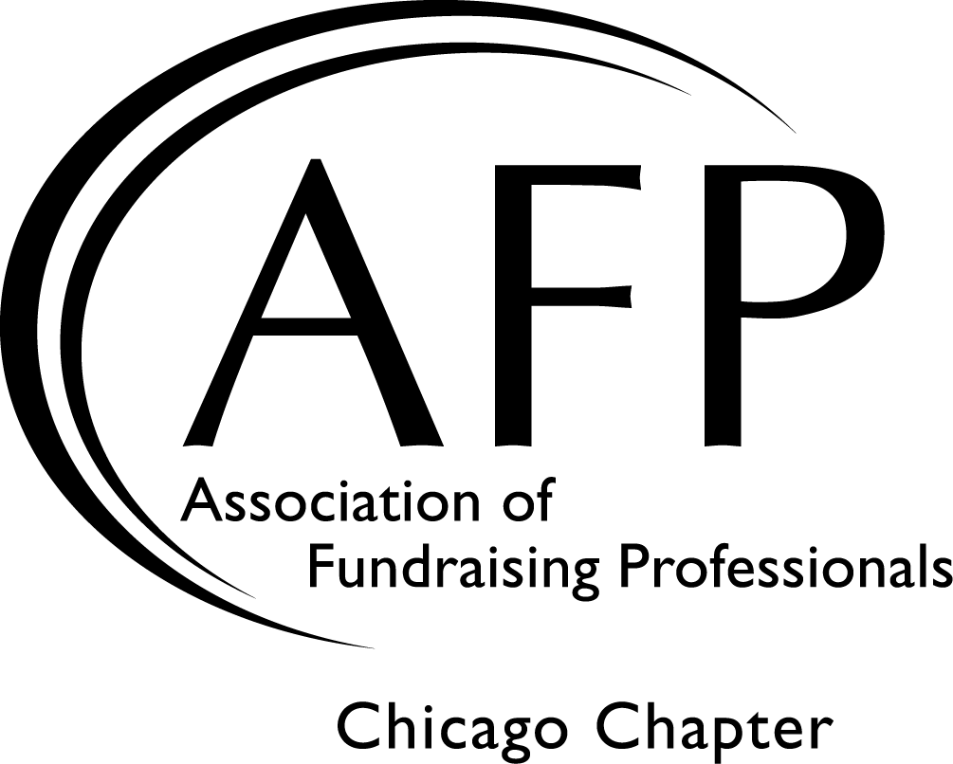
PROFESSIONALS CHICAGO CHAPTER

PEER MENTORING PROGRAM

Mentor Application

CFRE: Yes No
Name: Current AFP Chicago Member: Yes No
Title: Email:
Organization:
Organization Address:
Home Address (optional):
Telephone(s) Day: Eve:
I have access to a car and am willing to travel to meet my protégé: Yes No
My travel time by car should be no more than: No preference 30 minutes 60 minutes
I am willing to travel: No preference or (check all that apply) North South East West

A COPY OF YOUR CURRENT RESUME IS REQUIRED WITH THIS APPLICATION

Years in Development:
SPECIAL INTEREST: Check those of interest to you:
I am interested in coaching someone in diversifying their skills
I can assist someone who wants to add racial/cultural diversity to their board and donor base
I would like to assist someone charting his or her career path
I am willing to serve as a resource for someone new to the area for specific projects
Other

THREE STRENGTHS I BRING TO THIS RELATIONSHIP:
1)
2)
3)
What would you look for in an ideal protégé both personally and professionally? (use as much space as you like)
Please do not include my match information in the “Members On The Move” section of the AFP Chicago newsletter.
If selected, I will attend the mandatory kick-off event. (Details available on our website.)
I have read the program details and am committed to participating for one full year.

Signature: Date:

Please EMAIL this application and a copy of your resume to peer-mentoring@afpchicago.org
or mail it to AFP Chicago Chapter Office; 1717 North Naper Blvd, Suite 102, Naperville, IL 60563

A very special thank you to our sponsor:

